The following additional files for the 2026 Beaver Dam Lake Permit Application can be accessed through the link below:
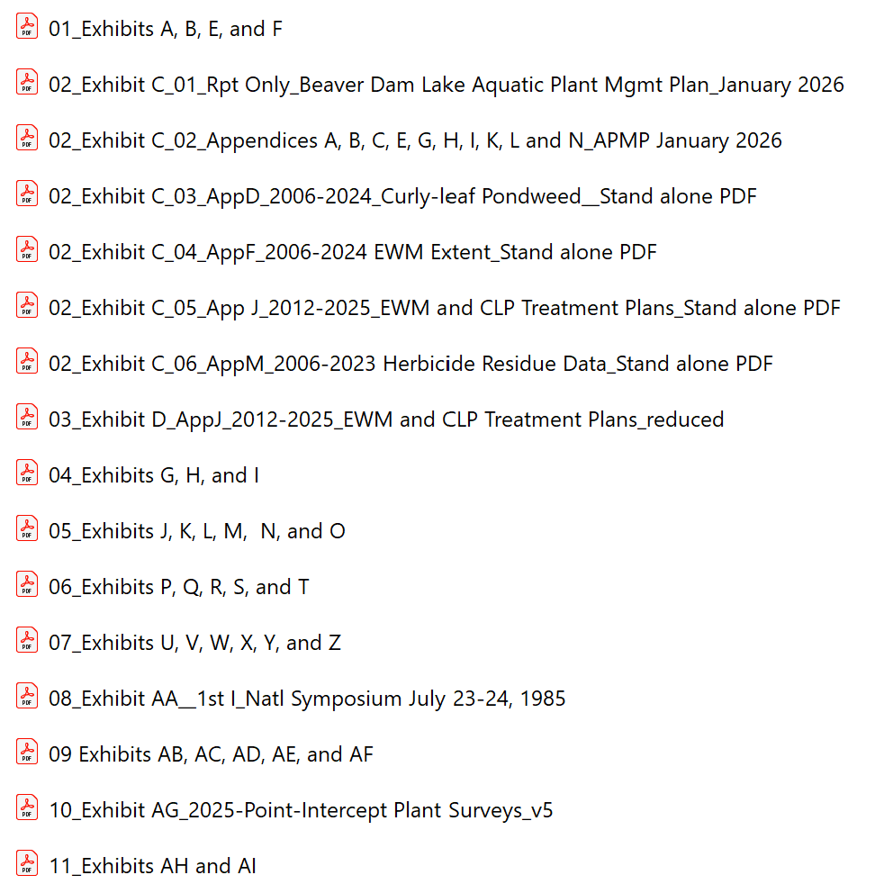
https://drive.google.com/drive/folders/1-XSpLvs2loq-QPtQn5Dh3jG4PPlvZ0_P?usp=sharing

